

Customer Service bot for a HR Recruitment agency

SOI-2020-2020-0028

Date of Submission: 02-Feb-2021

Submitted By:

SOI-2020-044

|  |  |
| --- | --- |
| 18009228 | Iskandar Syah |
| 18008635 | Liew Koh Jun |
| 18008532 | Greg Lau Kai Jie |
|  |  |

ACKNOWLEDGEMENTS

*FYP was a great opportunity for us students to hone our skills acquired from classes in the past semesters and also learn new skills at the same time. The team would like to especially thank our project supervisor Mr Ho Chee Wai for his utmost patience and guidance and support throughout these weeks. He has been nothing but kind and helpful to us from the start up till the end of the project, helping us delegate the tasks and giving ideas on what approach we can take for the project. We would also like to thank Mr Joshua Tan and Mr Peter Liew for their constructive criticism and advice given during our mid-semester evaluation.*

**TABLE OF CONTENTS**

ACKNOWLEDGEMENTS 2

ABSTRACT 4

1 Introduction 5

2 Project Specification and Plan 6

2.1 Project Overview 6

2.2 Functional Requirements 6

2.3 Project Plan 7

3 Business Analysis 8

3.1 Business Issues 8

3.2 Market Analysis 8

3.3 Business Solutions 8

4 System Design and Implementation 9

4.1 System Architecture 9

4.2 Detailed System Design 9

5 System Testing 10

6 User and Technical Documentations 11

6.1 User Documentation/Guide/Manual 11

6.2 Technical Documentation (Installation guide/Manual) 11

7 Conclusions 12

References 13

Appendices 14

Project Poster 15

**ABSTRACT**

*The team was tasked with creating a chatbot for a HR recruitment agency.*

*The chatbot's purpose is to improve quality-of-life aspects and ease of access to job seeking people and to provide a “one-stop centre” for all queries that they may have. The chatbot is built based on IBM’s Watson Assistant and Telegram as the channel and with the help of nodeRed, we were able to link the two. A website was created to show reports on how well the chatbot is doing.*

*The team met regularly and had meetings weekly with our supervisor who gave us pointers and guidance and how the project should be done.*

*Although the final product wasn’t how we envisioned it to be, The project was still able to fulfill the project requirements. In addition, extra features were also implemented into our final product.*

**1. Introduction**

*With the introduction of job channels, Job-seekers. However, with all the job listings shoved into a single channel, it is hard for job seekers to find a job listing that they might be interested in or have the qualifications for amidst all the job listings.*

*To streamline the process of allowing job seekers to find the job listings that they are qualified for or are interested in. Especially in these hard times, we want to ensure that we can help people looking for jobs by simplifying the job search process.*

*The major tasks include creating a chatbot, web scraping job listings & creating a database for reporting purposes. Our deliverable will be a chatbot that sends users job listings based on what they had enquired for.*

*We have solved the problem by streamlining the job searching process by making it clutter-free for the job seekers. The only job listings they will see are the ones that they have searched for e.g. Data Analyst.*

*It is notable that the solution we provide to job seekers only applies for jobs that are listed by Oaktree Consulting.*

**2 Project Specification and Plan**

# 2.1 Project Overview

*The objective at the end of the project is to allow the end users, which in this case is the job seekers to send their enquiries through the chatbot created; The chatbot will then pump the responses to the user with relevant answers from the knowledge base created. Whenever the users are unable to receive satisfactory results from the chatbot, they can choose to escalate their enquiries to a live agent through the chatbot as well.*

*The motivation for this project lies in providing convenience to end users, removing the need for them to wait for an available customer service agent to answer whatever queries they may have. By streamlining HR support queries with the use of automated dialog flows, it removes the necessity for having HR agent(s) constantly on their desks to provide customer support. And This notion will save time and effort from the HR team, while also reducing the cost from the need to have live HR agents on desk, providing live support. Inadvertently increasing HR’s productivity by allowing them to allocate their resources to other aspects of their job.*

*The scope includes developing a customer service chatbot for a HR recruitment agency to handle HR related enquiries.*

*The project works under the assumption that the chatbot will be able to support queries with the use of dialog flows, determining the specific dialog with intents & extities and returning the user an auto-searched answer from the knowledge base.*

## 2.2 Functional Requirements

*Functional Requirements*

|  |  |
| --- | --- |
| *Requirement ID* | *Requirement Statement* |
| *FR001* | *CS Bot should respond to any input it receives.* |
| *FR002* | *If CS Bot doesn’t understand the input, it should ask for rephrased and simplified input.* |
| *FR003* | *If CS Bot understands the input, it should respond with the correct information.* |
| *FR004* | *If CS Bot needs more information to find an answer, it should ask for more information.* |

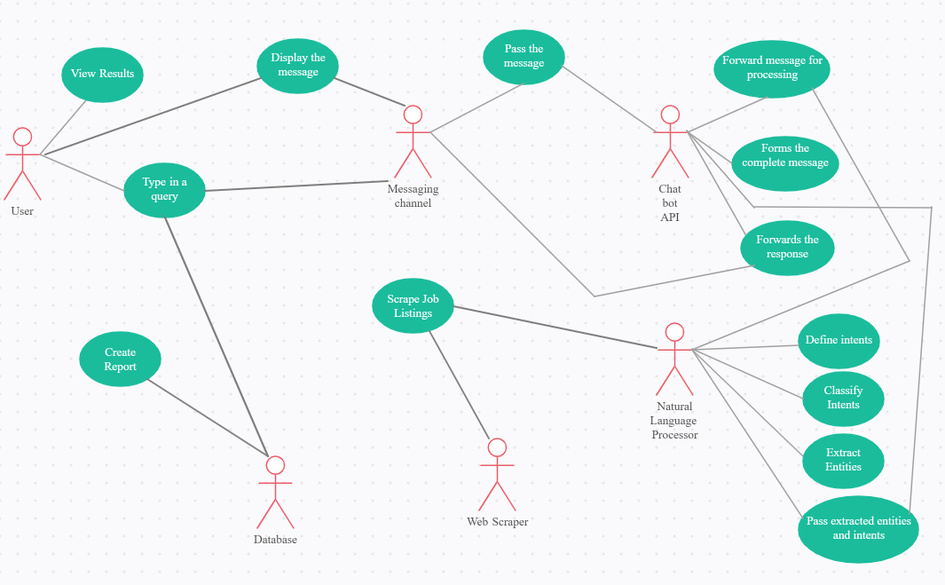

## 2.3 Project Plan



# 3 Business Analysis

**3.1 Business Issues**

*Oaktree Consulting’s Human Resource Department has been receiving plenty of basic enquiries regarding the job listings that they put up online. The need to respond to repetitive enquiries has led to a decrease in HR’s productivity, having spent so much time and resources on it.*

*End users also face less desirable waiting time before a customer service agent attends to them; Depending on the amount of traffic during the period, end users might suffer a longer waiting period.*

## 3.2 Business Solutions

*With CS Bot as part of Oaktree Consulting’s operations, time, cost & resources will be saved. A study conducted by ‘eLearning Industry’ on chatbots stated that businesses spend $1.3 trillion on 265 customer service calls each year. 80% of routine questions can be answered by chatbots. This frees up the time for staff to complete other work.*

*A chatbot’s service can be provided to the user at all 24 hours of the day, 7 days a week. This ensures that a person with an enquiry can have them answered at any time of the day and not just be subjected to office hours.*

*Thus, CS Bot is beneficial for both Oaktree Consulting and job seekers; Oaktree Consulting gets to save cost and resources whilst increasing productivity, job seekers can have their query answered at any time of the day.*

# 4. System Design and Implementation

## 4.1 System Architecture

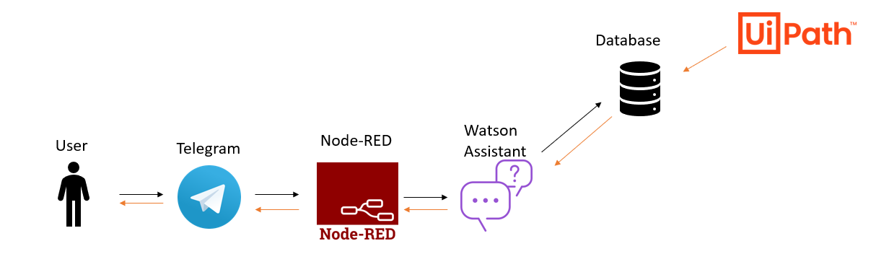

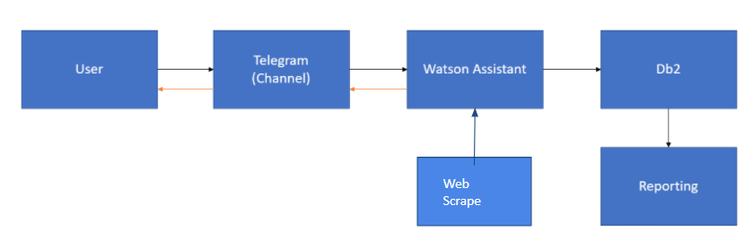

## 4.2 Detailed System Design

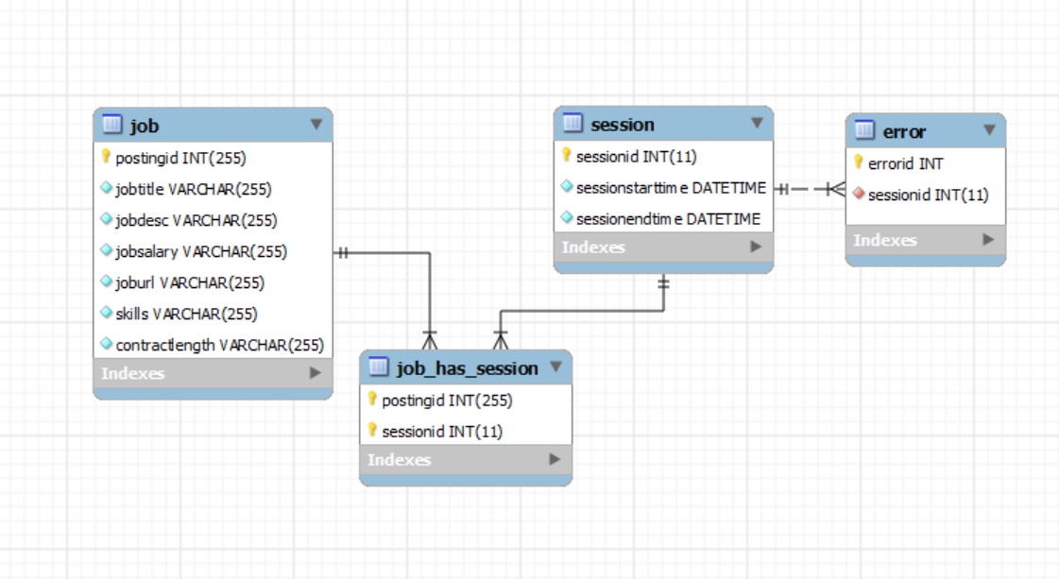

# 5. System Testing

**Test Case: User enquiring for ‘Data Analyst’ job on CS Bot**

|  |  |  |  |  |
| --- | --- | --- | --- | --- |
| **Test Step** | **Action** | **Test Data** | **Expected Result** | **Test Result** |
| **1** | Go to https://telegram.me/watsoncs_bot |  | CS Bot is displayed | pass |
| **2** | type “/job “ |  | CS Bot replies “ What job are you looking for?” | pass |
| **3** | type “data analyst” |  | displays job listings with the job title “data analyst” | pass |

**Test Case: User wants Oaktree Consulting contact information**

|  |  |  |  |  |
| --- | --- | --- | --- | --- |
| **Test Step** | **Action** | **Test Data** | **Expected Result** | **Test Result** |
| **1** | Go to https://telegram.me/watsoncs_bot |  | CS Bot is displayed | pass |
| **2** | type “/contactus “ |  | CS Bot replies  “You can visit us at:  101 Upper Cross Street  People’s Park Centre #04-44  Singapore 058357  Or email us at:  [jobs@oaktree.com.sg](mailto:jobs@oaktree.com.sg)  “ | pass |

**6. User and Technical Documentations**

## 6.1 User Documentation/Guide/Manual

***Telegram Chatbot Guide***

*List of functions available in the chatbot :*

*/oaktree - shows recruitment agency’s company description  
/job - allows user to search for jobs*

*/agent - connect to a human representative*

*/application - shows details how to submit resume*

*/translate - translates text to desired language*

*/joke - tells a joke to the user*

*/feedback - allows user to give feedback on the chatbot*

*/contactus - ask for email address or*

*/reset - resets the chatbot*

*1. Setup*

*1.1.1 Search “@WatsonCS_bot in the Telegram application and click on it.*

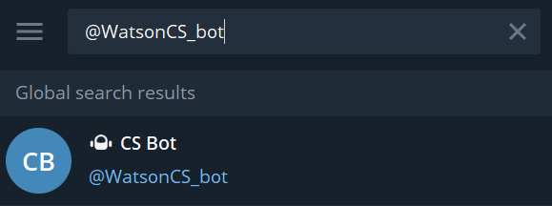

*1.1.2 Click/Touch “Start” (If the bot was stopped previously, “Restart will be shown in place of “Start”*

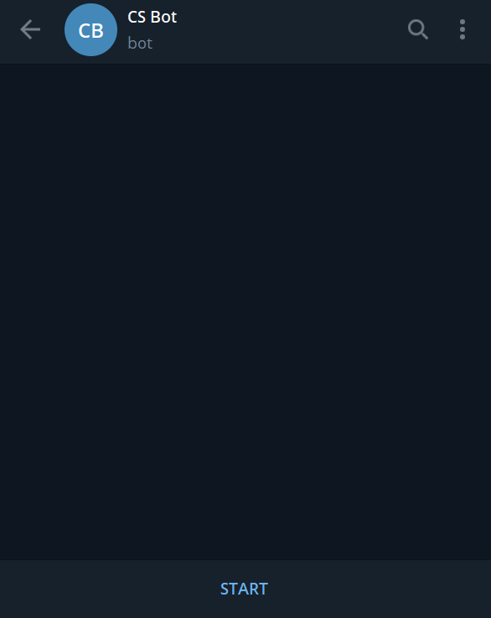

*1.1.3 Chatbot is successfully set up. User is now able to send messages to the bot*

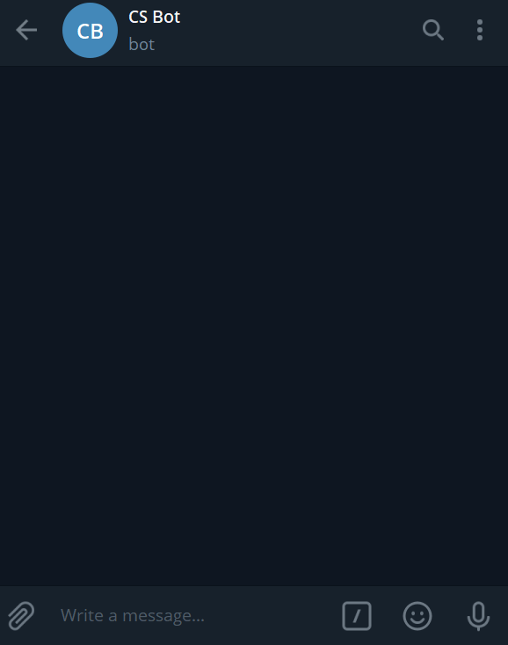

*2. Search for jobs*

*2.1.1 Click/Touch “Write a message…” and type “/job” and press send. Chatbot will reply with a prompt. Alternatively, users can converse with the bot like how they would converse with a live CS*

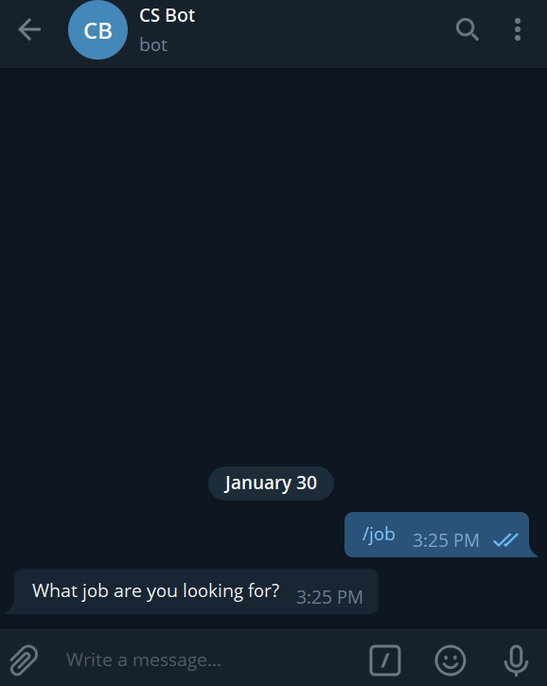

*2.1.2 For example, if looking for data analyst jobs, reply “data analyst” to the chatbot. The chatbot will reply with different data analyst jobs currently available.*

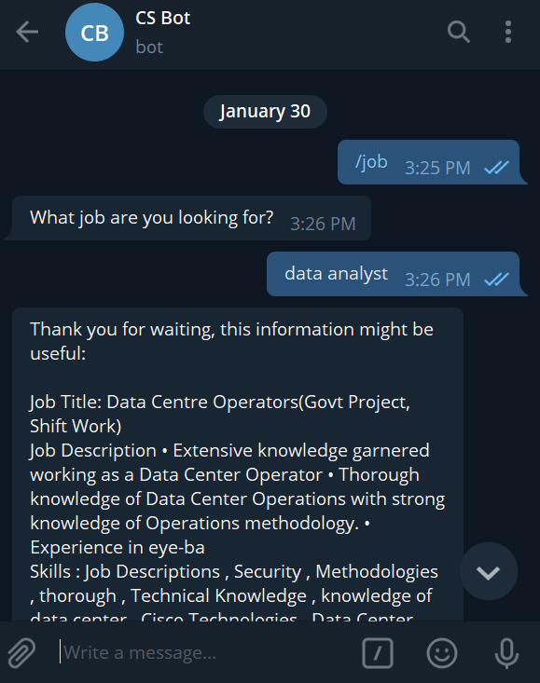

*3. Enquiring*

*3.1 Type in your questions the the chatbot will try its best to return satisfactory results*

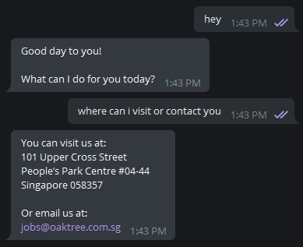

***Web Chatbot Guide***

1. *Set up*

*1.1 Insert script to Website’s HTML*

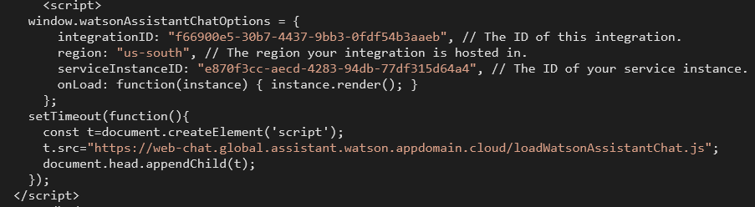

*1.2 After which, Website will show a hovering button at the bottom left as shown*

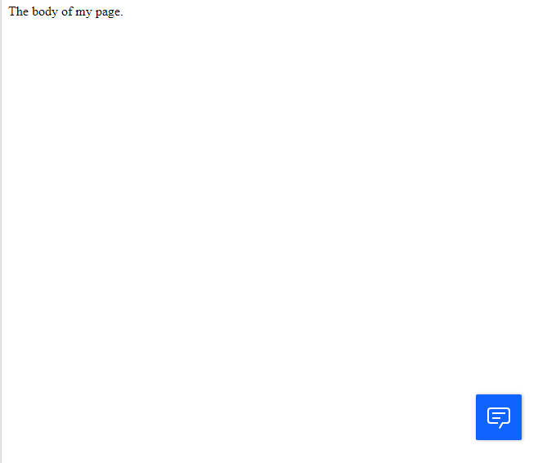

1. *Use chat bot*

*2.1 When users click on the chatbot trigger button, a pop up will show (below)*

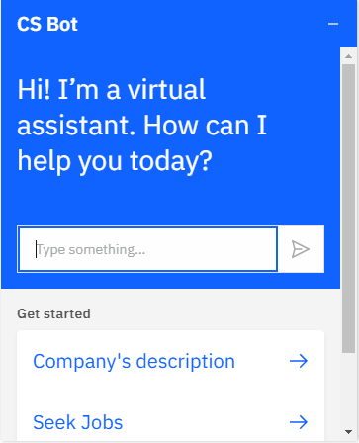

*2.2 Users can then input their enquires or questions using the chatbot*

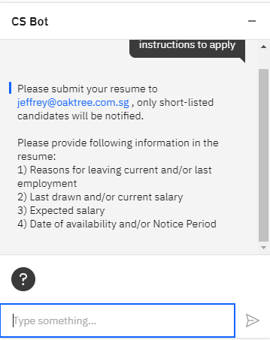

***Website guide***

*1. Access Website*

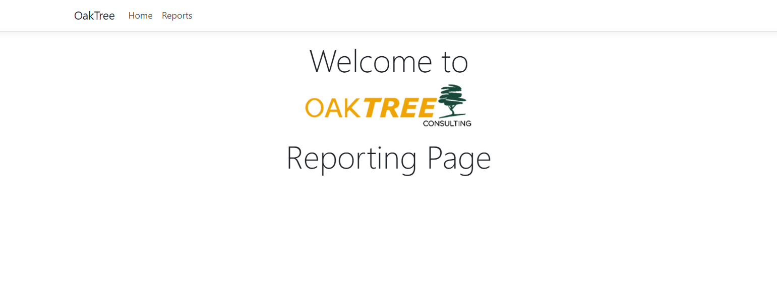

*2. Click “Reports”*

*3. Reports shown  
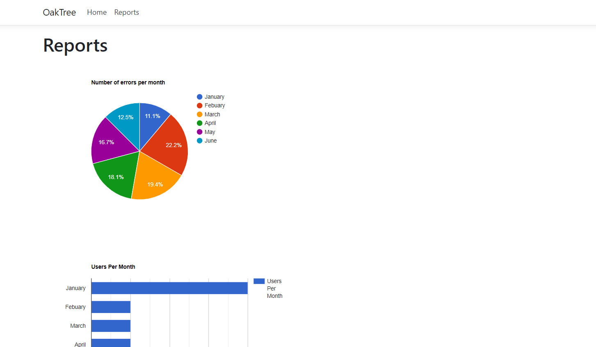*



Click

**7. Conclusions**

*Throughout this process of the past 13 weeks, we have learnt many valuable skills that we can take away with us when we enter the workforce. Both technical and soft skills can play an equally important role in the success of a project. Understanding how the different components and roles of the project work together to form a cohesive product is integral in having a solution that works as intended.*

*This project was a big hurdle for us as all of us had to pick up something new that was not taught in lessons. We had to do a lot of research, learning, trial & error in order to come up with our solution. The lack of communication caused by not being able to meet each other due to the global pandemic and being subjected to online meetings has caused miscommunication among team members which in turn has hindered our progress.*

***Greg*** *Summary of Accomplishments*

1. *Created Database in IBM db2 cloud database and updated it with the CSV file given from the web scrape*
2. *Create HTML MVC web page using Microsoft Visual Studio 2019*
3. *Implemented Google Charts as a charting tool into the web page for reporting*

*Challenges Faced*

1. *Scope Creep*

*Over the period of the project, my initial understanding of how the project would work, was that the chatbot was supposed to record the user’s replies and attachments (for example, the chatbot would ask the user the send his/her resume to the bot and the bot will store this for the recruitment agency to view.). However, as meetings passed I understood that the bot was just meant to return the user with information regarding jobs and the scope that I initially had, had changed, causing me to waste a lot of time researching on the initial scope and causing scope creep.*

1. *Time Management   
   Looking back at my work done, I felt unhappy with the outcome of my work done in the project. I thought hard about and came up with one conclusion, which was poor time management. Having other graded assignments due, I prioritised them higher than FYP, feeling that I had enough time to complete once I am done with graded assignments and eventually lost precious time that could be used in FYP.*

*From this experience, I learnt that time planning is extremely important, and I should have planned out a schedule to divide my time properly, so that I will have enough time for other commitments. Furthermore, in the future when I am working with real clients, project scopes are being changed to meet clients’ needs and with poor time management, there will be scope creep, which may cause the project to fail.*

1. *Unfamiliarity with software used  
   There were instances where I got stuck when doing my part of the project (Creating Database and Creating Website and Reports). I spent a lot of my time researching guides for the software and asking on Slack Overflow but could not find much help. Furthermore, I would keep using trial and error to try and solve an issue or figure out how to complete a related task, which also wasted a lot of time. What I should have done was instead of trying to complete everything myself, I should have asked for help from my teammates/peers/supervisors who may be familiar with the software and can provide suggestions or guidance regarding the tasks.*
2. *Lack of Interpersonal Communication*

*The team had difficulty communicating throughout the project duration. We did not have many opportunities to meet due to conflicting schedules in class times. This is further hindered due to the ongoing COVID-19 Pandemic, which made meeting up to discuss face to face challenging. Even with telecommunication devices available, we did not discuss much apart from regular weekly meetings with our supervisor. I learnt that communication is important as it allows us to share ideas and openly discuss ideas and faults with one another which will benefit the team greatly.*

***Koh Jun:***

*Accomplishments:*

1. *Building a Chatbot*

*While working on the Chat engine using IBM Watson Assistant, I've started to realise how annoyingly difficult it is to build a “Smart” chatbot. To be able to effectively recognise the end user’s intent requires a lot of background work to be done; For the user may be using slangs, short forms, informal wordings, etc. And that’s just the tip of the iceberg. The real challenge lies in the chatbot’s dialog fow: how the chatbot will reply to the user, and ultimately guiding the users to their answer.*

*For an instance, a user ask a chatbot for a restaurant suggestion; to lead to a satisfactory answer the bot will probably have to narrow down the user’s intent (eg. asking what type of food, budget, location, is restaurant fully booked, etc)*

*Although, I can confidently say that any other chatbot out there in the market is built better, more profound, and smarter than the chatbot built for this project; I’m still glad I'm able to receive many insights, knowledge, skills and experience to be able to work on one.*

1. *Integration Watson assistant with Channels*

*Setting up a Telegram Bot was relatively simple. But integrating Watson assistant with Telegram bot did cost me some time. As I have to look hard online for relevant software and guides to help me achieve this. Thankfully, there were plenty of helpful resources online to help me achieve so. “Stack Overflow” a Q&A website for programmers had plenty of answers to my questions; Making my integration process much smoother.*

*Aside from Telegram, I also did go the extra mile and look into integrating IBM Watson assistant with other popular platforms such as Facebook and Whatsapp. I was unable to set up Facebook Developer, which is a crucial part to allow for integration with IBM AI tools; This is due to me being unable to verify my facebook developers account. As for Whatsapp, I was required to sign up for a Twilio account to integrate it. However, to sign up for a free trial on Twilio account, I was prompted to key in my payment information which I was uncomfortable with doing. Thus, I dropped the integration with Watson Assistant and Whatsapp.*

1. *Node-red*

*Node red is a flow-base development/programming tool. This is the tool I used to “wire” the IBM AI tools with the telegram channel. The primary reason I used node-red was to integrate Watson Assistant with Telegram. The secondary reason being to enrich the bot with other features such as speech-to-text, image recognition, translating, parsing, etc. While also allowing me to connect the Watson Assistant chat engine & Telegram bot to a database/storage, knowledge base (Watson Discovery), machine learning models (knowledge studio), etc. It is also notable that node-red entails me to do some coding on javascript too. But my takeaway here is to understand how to construct a flow, while at the same time integrating tools and functions all together into one flow; Which i thought was really cool and interesting.*

*I spent quite a chunk of my time working on the flow and the codes, through plenty of tries (trial and error) and the help of Stack Overflow forum and online resources, i was able to get it done.*

1. *Building knowledge base using Watson Assistant*

*While a chat engine can answer a user's questions, there comes times where the chat engine is unable to return an appropriate answer to the user. Let's use an example to further explain: a user may require the chatbot to dish out his account’s details and the chat engine most definitely do not have the list of users’ information since it’s only program to answer questions, that is when the chat engine will seek information from a knowledge base to fuel an answer.*

*Through the use of Watson Discovery, I was able to upload the scraped data done by Iskandar into the knowledge base. After which, I start to clean up, and organize the json data. By filtering the fields, allocating the entities/variable name to each of the fields such as: Job title, Job description, Job salary, etc.*

1. *Web scraping*

*During a point of the project, I did try to help out Iskandar with his web scraping because he didn’t find much progress with his. For my first try, I used python to extract the elements from the website’s elements/html. But I was unable to format the code in a way that the bot will be able to dish out the scraped data to the user in a satisfactory and organized manner.*

*My second try was using web crawling through IBM Watson Discovery’s AI. I was able to scrape from the Oaktree’s job listing telegram group and achieve some formatting using functions/codes in node-red. I was able to automate the scrape (every hour) as well. However, the answers provided to the end users were insanely cluttered, the chunks of job listing were all grouped together; I did take a screen recording of the results dished out by the chat bot.*

*Update: Nearing the end of the project, I was able to successfully declutter the results given by the chatbot in a more “readable” way after messing with it for a while. But i still chose to stick with Iskandar’s scrape data; As even though it is not automated, his scraped data (json) was presented in a way that i can format the text well enough to produce an “easy to read” answer to the users.*

*Challenges:*

1. *Unfamiliarity with the tools & software*

*Using IBM’s AI tools such as Watson Discovery and Watson Assistant was relatively okay. There were plenty of tutorials out there to help expedite the learning process and the tools were quite user friendly as well. As for using node-red, it sparked quite a bit of problems. There were times where the entire flow does not work just because of a new additional line or node I add in. And trying to spot these errors can be frustrating. Sometimes I waste time trying to search for an error, when the underlying issue is the coding itself. Certain lines/nodes I added also caused the entire flow to stop working, even though I backtracked and deleted the line/node; The flow still wouldn’t work. So i have to redo the flow from scratch several times since i didn’t create a backup/extra flow. But with trial and error, I was still able to complete the flow.*

1. *Scope creep*

*Through our meetings, we were straying more and more further from our original project scope; Tons of unneeded and extra features were added in, some features were excluded, etc. This caused quite a bit of mess as when i looked back at the project requirements and scope, i realised that we are doing something completely different from what was asked. But since we are already in too deep, we stuck on with it…*

1. *Rushing my work*

*When I first started on the project, I thought I could rush and complete my tasks fast; So I can spend more time doing my Graded assignments and maybe get a part-time job or something. But no…*

*I finished the chatbot somewhere around week 3-5 and i thought i could just slowly modify and improve the dialog flow along the way, while i await for my teammates to be done with the database and web scraping for me to integrate with Watson Assistant and Telegram; But i was continuously tasked with things to do in the meantime. Ultimately making me feel that it was unfulfilling to try to get my work done quick.*

***Iskandar:***

*Accomplishments*

1. *Web scraped job listings using*

* *UI Path*
* *Python with BeautifulSoup*
* *OctoParse*
* *Grepsr*
* *Webscraper.io*
* *Watson Discovery*

*Tasked to web-scrape job listings that Oaktree Consulting has listed, I found many tools that can ease the burden of trying to web-scrape which is coding. Many software applications and even web browser extensions can users web-scrape data without the need for coding, just by pointing and clicking, the software will have a .csv file with the data field the user has selected in a matter of minutes. This makes web-scraping accessible to anyone with little to no experience who might be interested in data collection.*

1. *Extracting Data fields*

*Extracting data that job seekers might be keen to know, Job Title, Salary, Contract Length, Description & Skills Required.*

*Challenges:*

1. *Automation/ Scheduling of web-scrape*

*The next step that comes after web-scraping data periodically or manually is automation or scheduling. To save time and resources, automation of web-scrape is highly important. Around week 10, my supervisor asked me to start looking into automation of scraping as a next step to the web scraping I have already done. Still insisting on using software to scrape instead of code, I scoured the internet to find a software that can automatically scrape data. I downloaded countless software applications and web browser extensions to find one that can scrape data automatically. Some of the software applications could scrape automatically but only if the user were subscribed to their premium plan that would cost upwards of $100 per month. At the 12th meeting, I was still in my search and experimentation of finding a software that can scrape automatically. I am the only one to be blamed for not starting the automation process earlier in the project.*

1. *Lack of self-discipline*

*In hindsight, I am extremely disappointed in my performance or lack thereof. I regret only working at the last minutes before a weekly meeting and not contributing much to the team. I know that I could’ve done so much better if I had more discipline in my work. Although I am still doing my job as the Team Coordinator as a mediator between my 2 teammates, I feel as though I was not pulling my weight enough. I prioritised many other worldly desires over my project. Being at the comfort of my own home while meetings were conducted, I did not feel any sense of urgency up till the last week before submission. I am thoroughly disappointed and frustrated at myself for not being able to automate the script correctly.*

1. *Lack of communication*

*The lack of communication between teammates and supervisor even has hindered our progress significantly. We didn’t have a good and deep understanding of other team members’ tasks and how their part would work with mine to produce a cohesive solution. The only time the team would talk about the project is during the meeting and we end up forgetting where we left off the last meeting frequently. I wouldn't know of my teammates’ progress until the weekly meeting which made it hard to collectively understand the progress of the project. I had a part to play in the lack of communication between the team and now understand how integral communication is for the success of a project.*

*Attempts:*

*On 01/02/2021, 2 days before submission, I attempted to write a python script that will scrape job listings off of sg.indeed.com. The script would convert the data into .csv format. I then used digitalocean.com to set up an Ubuntu server in the cloud. I uploaded my web-scraper script to GitHub.com and accessed it via the Ubuntu server. I then chose for the script to run at 08:00 daily.*

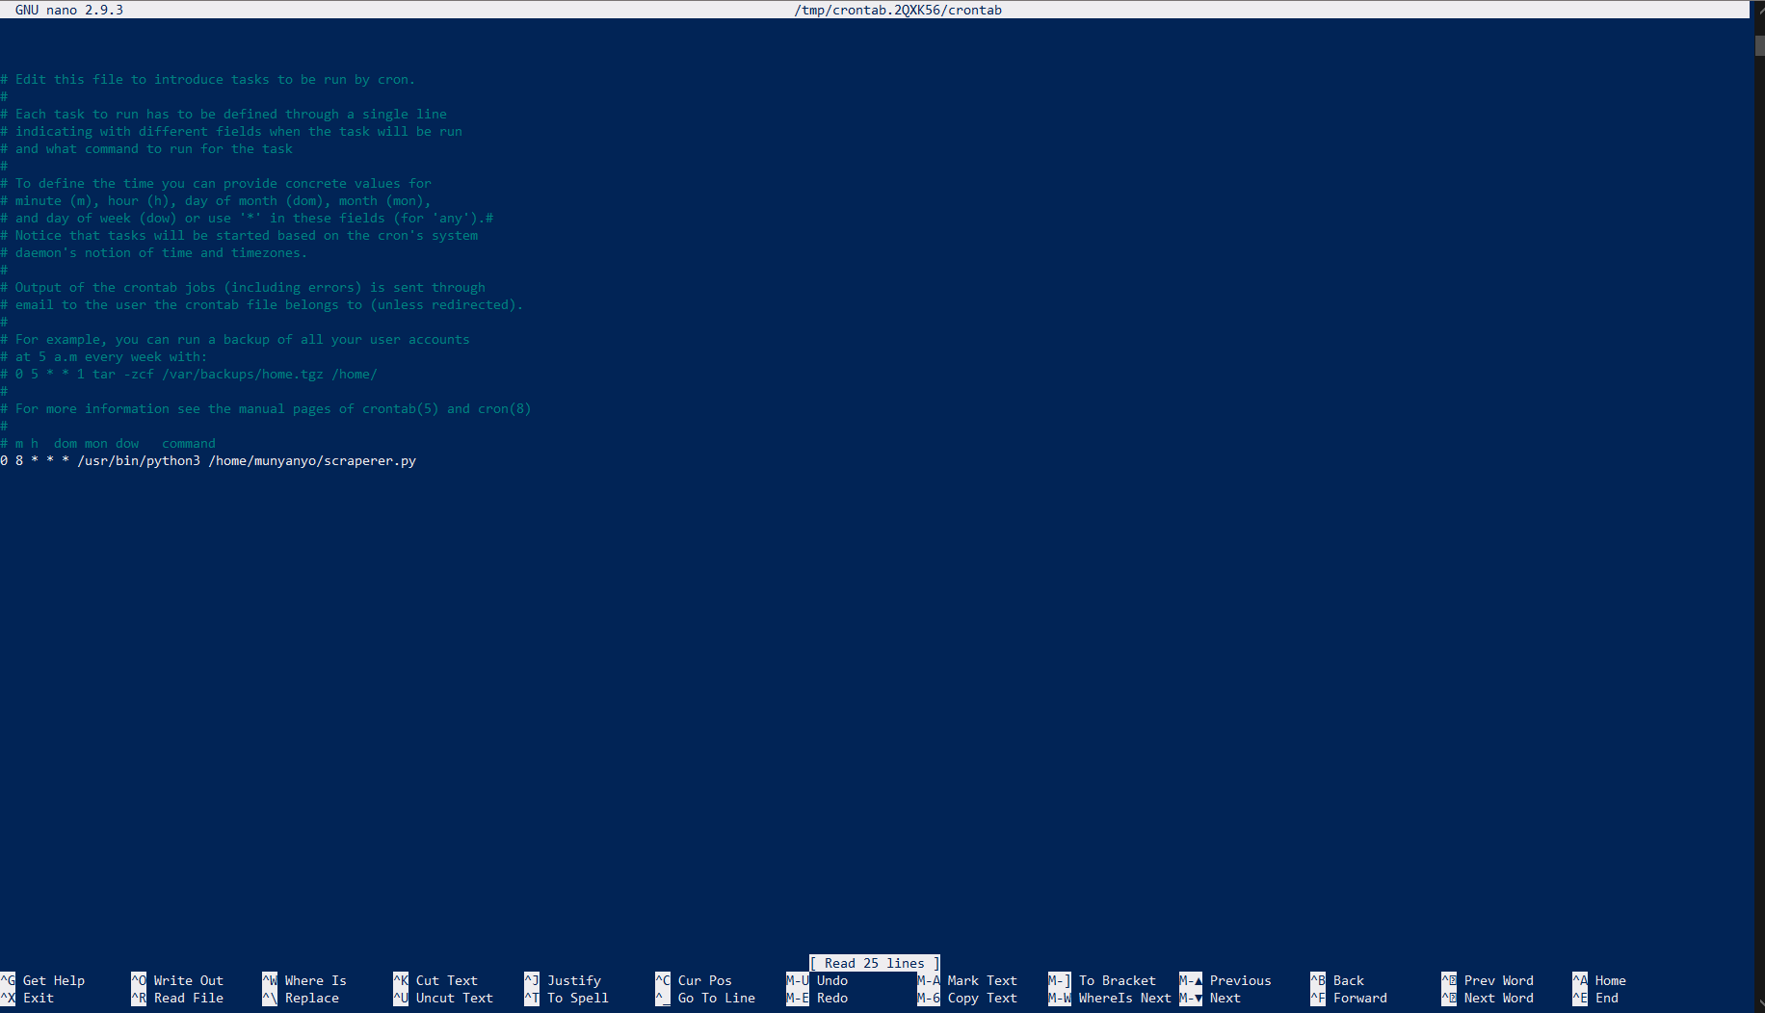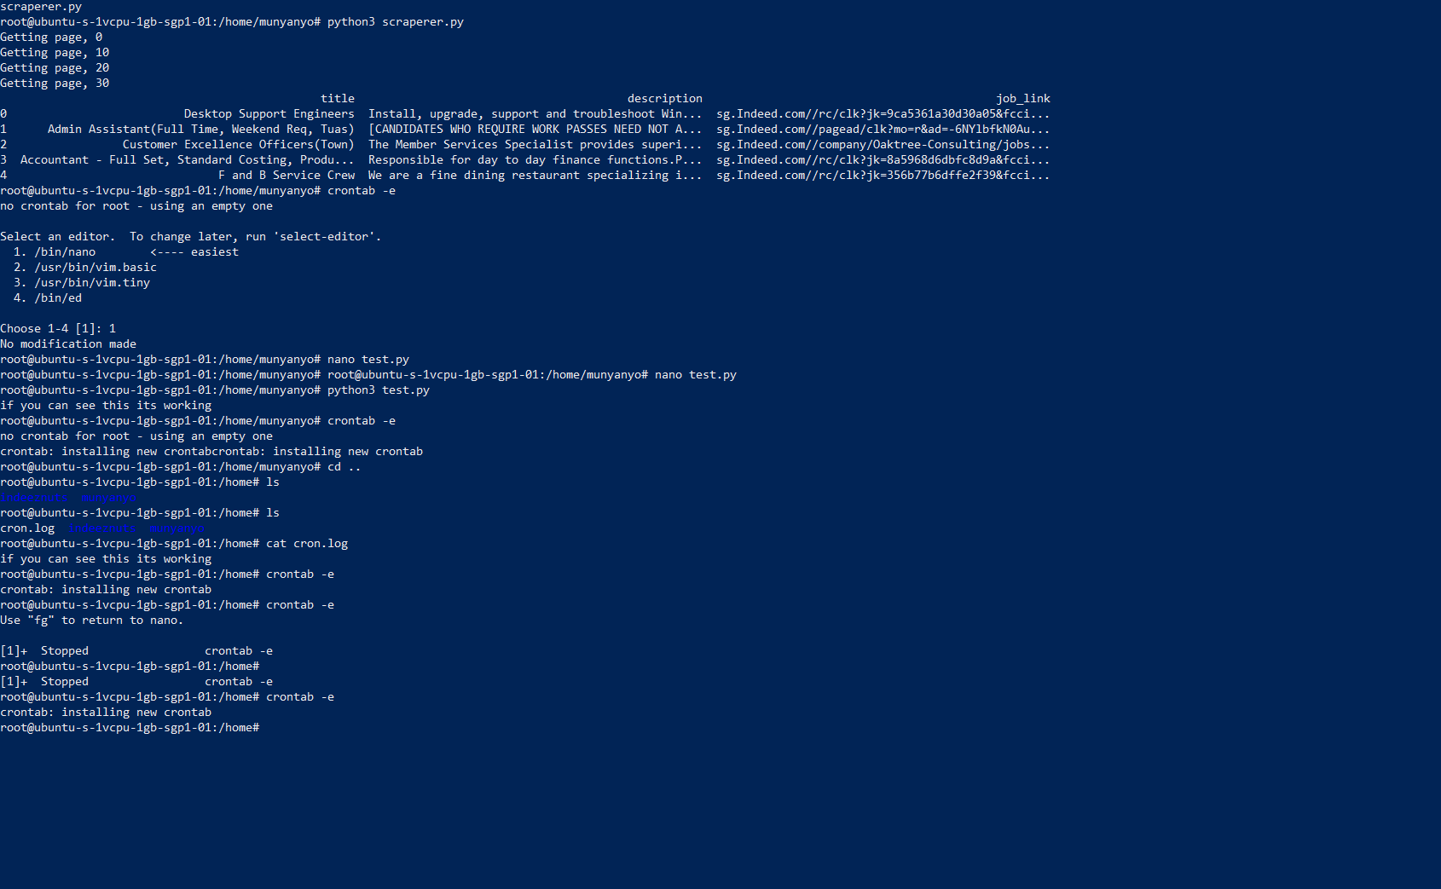

# References

* **Acknowledge** any work, statement or definitions copied
* Citation **style**
  + IEEE citation style
    - [1] D. Ingre, *Survivor’s guide to Technical Writing.* Mason, OH: South-Western Educational, 2003.
    - Usage: Some text. [1]
  + APA citation style
    - Dubeck, L. (1990). Science fiction aids science teaching. *Physics* T*eacher, 28,* 316-318.
    - Usage: Some text. (Dubeck, 1990)
  + MLA citation style
    - James, Nancy E. "Two Sides of Paradise: The Eden Myth According to      Kirk and Spock." Spectrum of the Fantastic. Ed. Donald Palumbo.      Westport: Greenwood, 1988. 219-223.
    - Usage: Some Text. (James 1)

# *https://elearningindustry.com/chatbot-helps-improve-performance-productivity-workplace-5-ways#:~:text=Chatbots%20help%20businesses%20save%20on,provide%20other%20cost%20savings%20too.Appendices*

# Project Poster

